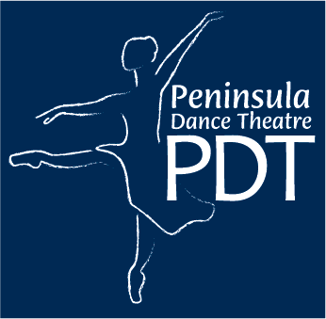
Mallory Morrison, Artistic Director
515 Chester Ave.
Bremerton, WA 98337
(360)-377-6214
Please Return the Completed Form by October 1st
Vehicle owner’s permission:

I hereby give permission for use of my vehicle for transporting students to the following purpose/activities:

I certify that the vehicle and driver are insured for the following limits of liability:

Bodily injury: $25,000 per person, $50,000 per occurrence (state minimum req.)
Property damage $10,000 (state minimum requirement)

My insurance number:_______________________________
Policy Number:_____________________________________

I understand that my insurance company is primary in the case of any incident and that any other liability, if any, would on be in excess of the limits stated above.

______________________________________ _____________
Signature of parent or over 18 owner Date

Driver’s Declaration:
I certify that I have a valid Washington State Driver’s License.
I declare that my vehicle is in sound mechanical condition, and my vehicle can transport ____ people, including driver with safety belts, and I agree to all occupants wearing safety belts as required by law.

____________________________ __________________________ _________
Driver Signature Printed Name Date

